**FORMAN CHRISTIAN COLLEGE**

**(A CHARTERED UNIVERSITY)**



**TEST CASES & UNIT TESTING**

**REPORT**

**Course Title:** *Software Quality Assurance*

**Course Code:** *CSCS 351-A*

**Name:** Aleena Khalid - 221523598

**Submitted to:** Dr. Saad Bin Saleem

**UNIT TESTING:**

It is a type of software testing where individual units or components of a software are tested. The purpose is to validate that each unit of the software code performs as expected. Unit Tests isolate a section of code and verify its correctness. A unit may be an individual function, method, procedure, module, or object.

**TEST CASES:**

A test case is a set of actions performed on a system to determine if it satisfies software requirements and functions correctly.

**TESTING SUITE:**

A test suite is a collection of test cases that are grouped for test execution purposes.

**UNIT TESTING FRAMEWORK:**

A software tools used to support writing and running unit tests, including a foundation on which to build tests and the functionality to execute the tests and report their results.

There are multiple software systems for testing e.g. Junit for Java code, PYunit for Python code, PHPUnit for PHP code, etc.

**WRITING AUTOMATED TEST CASES:**

I will be using **JUnit Testing** framework for writing automated test cases in Java.

* Test Case #1:

“Add Two Integers”

***Running the test case successfully:***

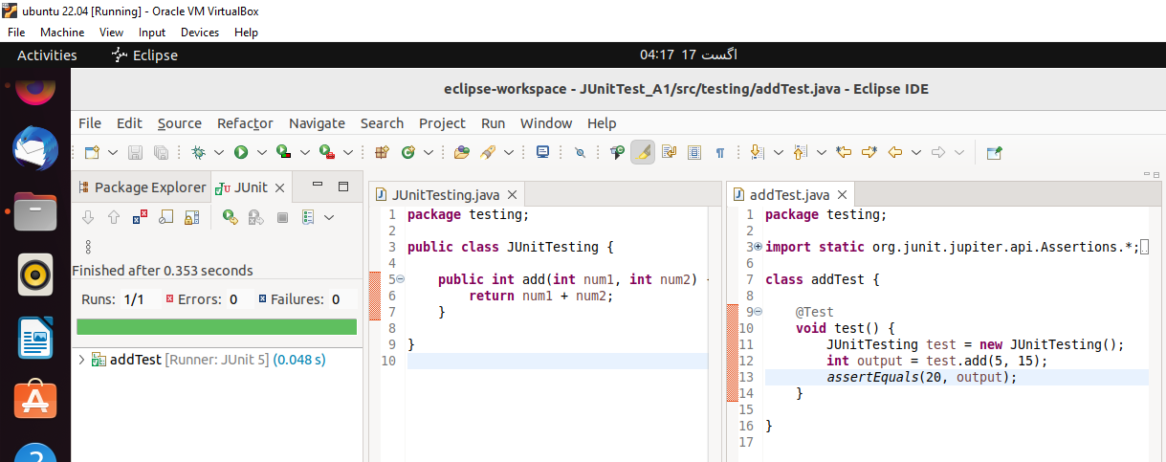

Figure 1: Add Test show result pass

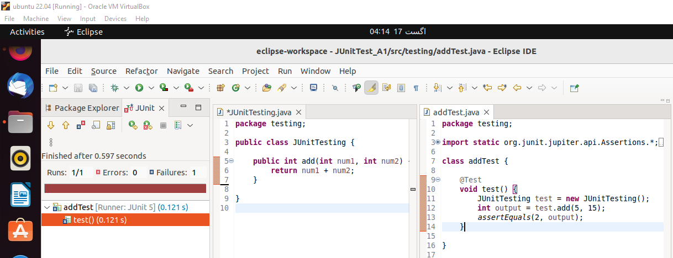

Figure 2: Add Test show result fail

* Test Case #2:

“Subtract Two Integers”

***Running the test case successfully:***

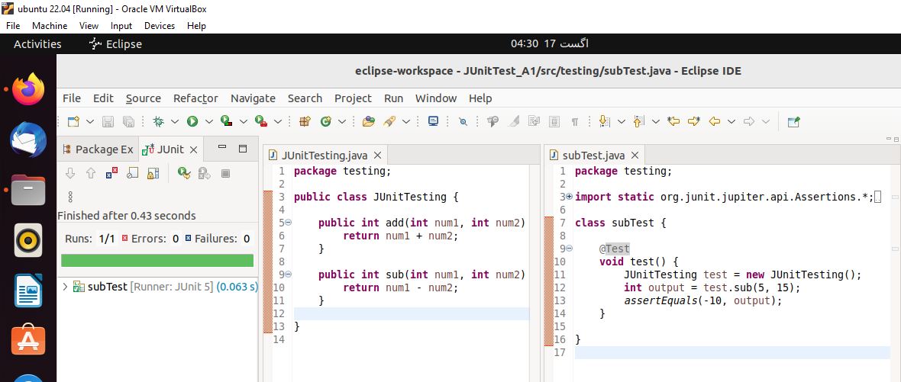

Figure 3: Sub Test show result pass

* Test Case #3:

“Multiply Two Integers”

***Running the test case successfully:***

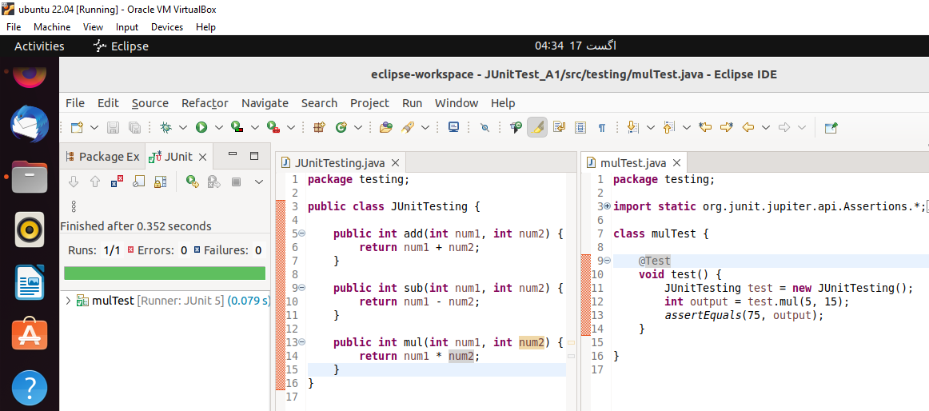

Figure 4: Mul Test show result pass

* Test Case #4:

“Division between Numbers”

***Running the test case successfully:***

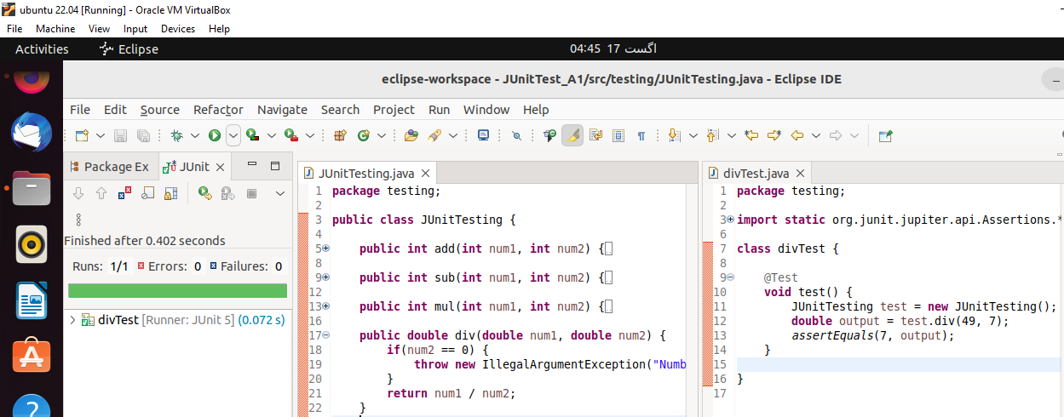

Figure 5: Div Test show result pass

* Test Case #5:

“Reverse the Word”

***Running the test case successfully:***

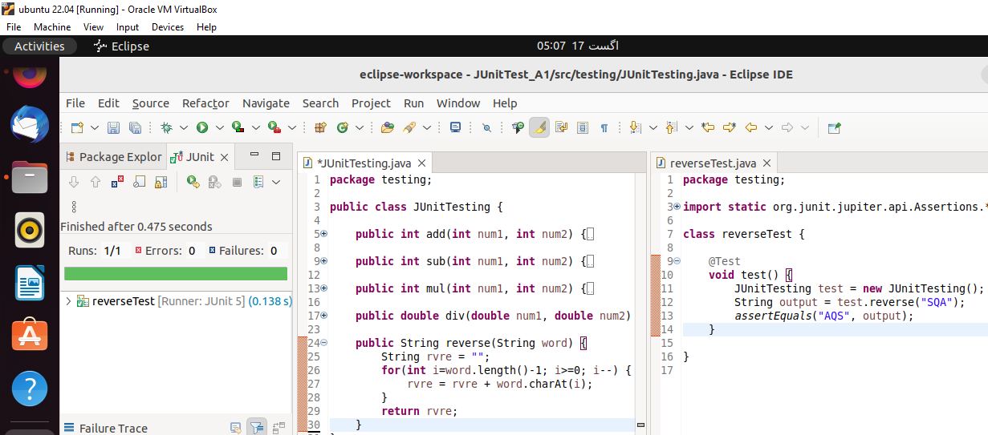

Figure 6: Reverse Test show result pass

* Test Case #6:

“Even or Odd”

***Running the test case successfully:***

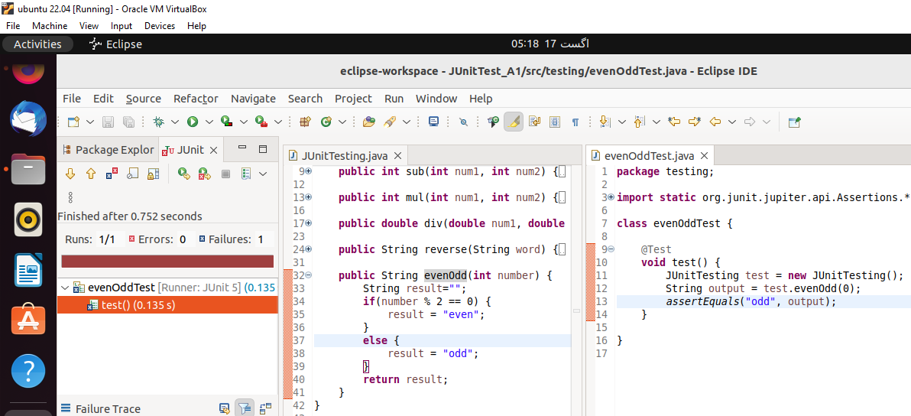

Figure 7: EvenOdd Test show result fail

* Test Suite:

“All Tests Together”

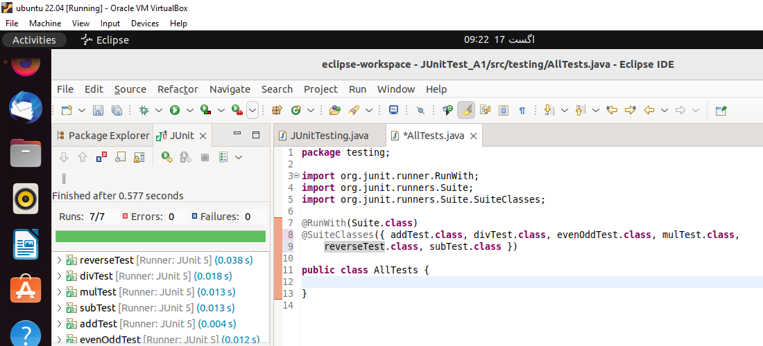

Figure 8: All Tests pass successfully